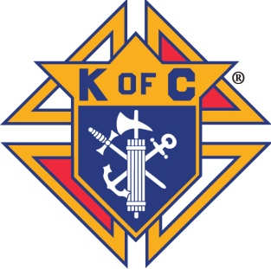
Important Announcement
Formation and Knighthood Degree
Saturday October 26th 2019
Hosted by Berlin Council 1547
All Saints Catholic Parish Hall N8566 State Road 49 Berlin WI 43923
Located 1 mile south of Berlin at the top of the hill
Formation Degree
Registration- 10 am
Installation – 10:30 am No Fee for this Degree
Lunch - 11:30 am cost for hot sandwich plate and drink, $5.00
Knighthood Degree
Registration – 11:30 am
Installation – 12 noon $7.00 fee for this Degree
Includes a $5.00 medallion fee and a $2.00 equipment fee.
Please be on time!!!!Late entries will not be granted access into the Degree Chambers!
Degree closing date is October 21st. After that date call for details
Degree reservations accepted by mail or e-mail.
Registration forms and list of names must be provided and are appreciated. For further information or last minute availability contact Rob Kurczek at 920-290-2270, or robkofc@centurytel.net

Formation and Knighthood Degree
Candidate Reservation Form
Saturday October 26th^{th} 2019
Hosted by Council 1547 Berlin WI 54923. At All Saints Catholic Parish Hall N8566 State Road 49. 1 mile south of Berlin at the top of the hill. Use the Far East doors and parking.
Council No: ___________ District No: _____________
Form submitted by: ___________________________________
Title: _________________ Phone No: ___________________
Degree reservations closing date by October 21st 2019. Call for info after this date. Rob Kurczek at 920-290-2270.
Formation Degree: Registration at 10am. Degree at 10:30 am
Lunch: 11:30 am
Knighthood Degree: Registration at 11:30am. Degree at 12 noon
Fees:
Total candidate count for Formation Degree: _____ No charge
Total candidate count for Knighthood Degree:_____ $7.00 each______
Lunch count for candidate and observers:_______ $5.00 each ________
Total enclosed for Degrees and Lunch: _____________
Mail checks payable to: Berlin Council 1547
Mail forms and checks to: Rob Kurczek. N8359 CTY RD A Berlin Wi 54923. Please have candidate bring their current membership cards!!!!
Formation and Knighthood Degree
Candidate Information Form
Saturday October 26th 2019
All Saints Catholic Parish Hall
N8566 State Road 49 Berlin WI 54923
One mile south of Berlin at the top of the hill. Use the Far East doors and parking.
Council NO:__________ District No:________
Please print Indicate Degree achieved
Last name MI First name Membership No: 1st or 2nd Degree

Please send in by October 21st!!! Or call for late registration

